Pressed Concrete Pavers – Mortar Set Installation Guide Specifications

Section 32 14 16

Part 1 – General

1.01 RELATED DOCUMENTS
- Drawings and general provision of contract, including General and Supplementary Conditions and other Division 1 Specification Sections, apply to work of this Section.

1.02 SUMMARY
- Perform all work required to complete, as indicated by the Contract Documents, and furnish all supplementary items necessary for the proper installation of Pressed Concrete Pavers.
- The paver installation shall be absolutely rigid, and even large slabs when subjected to vehicular traffic, shall not be displaced.
- Related Sections include the following:
  - Section 31 22 00 Grading.
  - Section 31 23 00 Excavation, Backfilling and Compaction.
  - Section 32 16 00 Concrete Paving, Walks, Curbs and Gutters.
  - Section 07 00 00 Modified Bituminous Sheet Membrane Waterproofing.
  - Section 07 92 00 Sealants.

1.03 REFERENCES
A. Testing Standards
  - ASTM C-150 - Specification for Portland Cement.
  - ASTM C-127 - Test method for specific gravity and absorption of Course Aggregates.
  - ASTM C-128 - Test method for specific gravity and absorption of Fine Aggregates.
  - ASTM C-136 - Test method for sieve analysis of Fine and Coarse Aggregates.
  - ASTM C-140 - Testing for sampling and testing Concrete masonry and related units.
  - ANSI A326.3 - Dynamic Coefficient of Friction.
  - ASTM C-1028 - Static Coefficient of Friction.
  - ASTM C-1262 - Test Method for Evaluating Freeze-Thaw Durability.
  - WTCL 99 - Load Carrying Capacity.
B. Tile Council of America (TCA)
  - Current TCNA F101 - Mortar Installation
  - Current TCNA EJ171 - Movement Joints

1.04 SUBMITTALS
- Submit under provisions of Section 01 30 00.
- Product Data:
  - Manufacturer's data sheets on each product to be used, including preparation instructions, installation methods, storage, handling requirements and recommendations.
  - Submit test results for compliance with performance requirements specified herein.
  - Submit written instructions for recommended maintenance.
- Shop Drawings:
  - Layout drawings of each paved area showing the pattern of pressed pavers, indicate pavers requiring cutting, drainage patterns, drains and relationship of paving joints. Include details of setting beds, noting all materials and their thickness, and show details at curbs and vertical surfaces.
  - Details of custom (nonstandard) curbs and stair tread/risers, include methods of installation.
- Samples:
  - Submit sample to be selected by Architect / Engineer / Landscape Architect / Owner from manufacturer’s available standard and custom colors.

1.05 QUALITY ASSURANCE
- Manufacturer Qualifications: All products covered under this Section shall be produced by a single manufacturer, unless otherwise specified, with a minimum of fifteen (15) years proven production of this concrete paver product.
- Installer Qualifications: Installer shall have a minimum of five (5) years proven specialized construction experience with this product and be capable of estimating and building from blueprint plans and details, in addition to proper material handling. All work must comply with local, state/provincial licensing and bonding requirements.

1.06 MOCK-UP INSTALLATION
- Prior to the start of pressed concrete paver work, construct mock-up of each type of pressed paver size and pattern area for the owner and architect to review. The mock-up will be at the project site or at a location mutually agreed to by the owner and contractor.
  - Construct the mock-up installation in a minimum 4-foot by 4-foot area of typical concrete units and slabs with all setting beds, joints, edge and curb details as shown on the drawings.
  - After review of the mock-up, it will be retained and used as a standard of quality for the pressed concrete paver work. At completion of the work, remove the mock-up installations and related materials from the project site. If the mock-ups are incorporated in the actual construction, record their locations and sizes on the actual built record drawings for the project.

1.07 DELIVERY, STORAGE AND HANDLING
- In accordance with provisions of Section 01 60 00.
- Pressed concrete pavers to be banded on pallets and delivered in original unopened packaging with legible manufacturer identification, manufacturing number and manufacture date.
- Protect pressed concrete pavers during shipment, storage and construction against damage.

1.08 PROJECT CONDITIONS
- Maintain environmental conditions (temperature, humidity and ventilation). Do not install products under adverse environmental conditions.
PART 2 – PRODUCTS

2.01 MANUFACTURERS
- Acceptable Manufacturer:
  - Wausau Tile, Inc. | 1.800.388.8728 | info@wausautile.com | www.wausautile.com
- Choose from:
  - H-Series: EcoPremier, Estate, Estate II, Frontier, Galaxy, Quattro Series, Ridgeline and Riverside.
  - V-Series: Apex, Aurora, Ballast, Blasted Glass, Brilliance, EcoPremier, ExpoStone, Expressions, Exterior Terrazzo, Granitex, Northern Lights, Ocean View, Riverbend, Sand Series, Series Sesto, Stoney Creek, Textured Granite, Timber, UltraFace and Washed Glass.
- Substitutions: Not permitted.
- Pressed concrete pavers, equal in appearance and function and meeting these specifications, will be acceptable when the specified submittals from Section 00 26 00 are approved in writing by the Architect prior to bid.

2.02 MATERIAL REQUIREMENTS
- The pressed paver system shall include the following components:
  - Portland Cement: ASTM C-150 specifications for Portland Cement,
  - Aggregates: All aggregates are tested in accordance with ASTM C127, ASTM C128, and ASTM C-136 specifications. Aggregate shall be blended to meet individual project requirements.
  - Coloring: Pigments used shall be inorganic and alkali resistant and used per manufacturer’s recommendations.
  - Factory Applied Sealer: Colorless slip and stain resistant penetrating or acrylic sealer.

2.03 PERFORMANCE REQUIREMENTS⃰
⃰ Performance Requirements based on 24”x24”x2” pressed paver
- H-Series
  - Compressive Strength: (ASTM C-140) The average compressive strength shall not be less than 9,500 psi with no individual unit less than 8,000 psi.
  - Water Absorption: (ASTM C-140) The average shall not be greater than 4.5 percent.
  - Flexural Strength: (ASTM C-140) Shall not be less than 1800 lbs. avg.
  - Center Load: (WTCL 99) Pressed paver units shall have a tested center load capacity of 2,000 lbs.
  - Freeze/Thaw: (ASTM C-1262) Durability of the pressed paver shall meet the freeze/thaw tests per Section 8, shall have no breakage and not greater than 1 percent loss in dry weight of any individual unit when subject to 100 cycles of freeze/thaw.
  - Dynamic Coefficient of Friction: (ANSI A326.3): Wet: > 0.42
  - Sizing Dimensions: Shall not differ by more than 1/16 inch (1.6 mm) from width, height, length or thickness. Unit shall conform to a true plane and not differ by more than 1/16 inch (1.6 mm) in either concave and/or convex warpage.
- V-Series
  - Compressive Strength: (ASTM C-140) The average compressive strength shall not be less than 8,000 psi with no individual unit less than 7,500 psi.
  - Water Absorption: (ASTM C-140) The average shall not be greater than 6 percent.
  - Flexural Strength: (ASTM C-140) Shall not be less than 1200 lbs. avg.
  - Center Load: (WTCL 99) Pressed paver units shall have a tested center load capacity of 1,850 lbs.
  - Freeze/Thaw: (ASTM C-1262) Durability of the pressed paver shall meet the freeze/thaw tests per Section 8, shall have no breakage and not greater than 1 percent loss in dry weight of any individual unit when subject to 100 cycles of freeze/thaw.
  - Dynamic Coefficient of Friction: (ANSI A326.3): Wet: > 0.42
  - Sizing Dimensions: Shall not differ by more than 1/16 inch (1.6 mm) from width, height, length or thickness. Unit shall conform to a true plane and not differ by more than 1/16 inch (1.6 mm) in either concave and/or convex warpage.

2.04 INSTALLATION MATERIALS
- Mortar Setting Bed Method:
  - Portland Cement Mortar Mix: Approved mortar mix for Thick Bed (1 1/4 to 2 inches) Mortar Mix. Basis of Design: ANSI A108.1 A, B, or C. May be a Pre-Blended Mortar Mix.
  - Thinset: The use of an ANSI A118.4 Bonding Mortar or better is required. Basis of Design: Custom Building Products
  - Optional Reinforcement: Welded galvanized wire mesh used in thick mortar bed.
  - Water: Clean and free of deleterious acids, alkalies or organic materials.
  - Grout: ANSI A118.7 High Performance Ceramic Tile Grouts. Basis of Design: Custom Building Products Prism Ultimate Performance Grout
  - Sealant, Back-up and Bond Breaker: As specified in Section 07 92 00 – Joint Sealants.
  - Pressed Pavers to be used in vehicular application must be a minimum of 2 3/4 inches thick.

PART 3 – EXECUTION

3.01 INSPECTION
- Examine all jobsite surfaces to receive the parts of the paving materials. Notify the contractor in writing of conditions detrimental to the proper and timely completion of the work. Do not proceed with the work until unsatisfactory conditions have been corrected. Installation of pressed concrete pavers and associated construction constitutes acceptance of the adjacent and underlying construction.

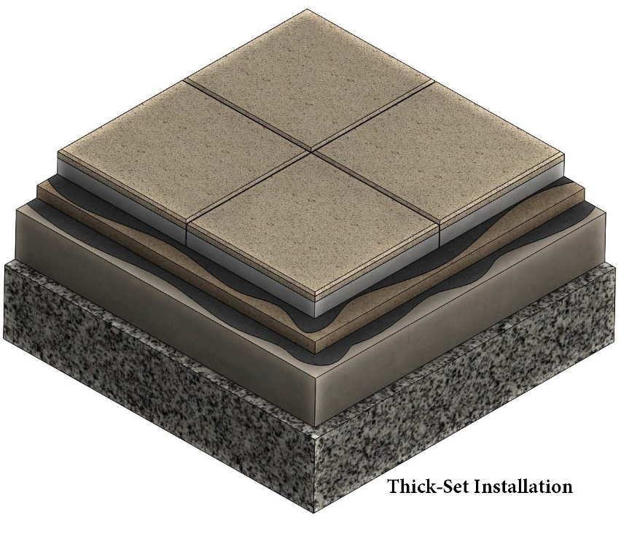
Wausau Tile architectural paver

Typical edge condition is 3/16” chamfer

slurry bond coat

1 ¼: Mortar bed with
Optional reinforcement

4” – 6” concrete

6”- 8” compacted road-grade
gravel (#6)

For vehicular applications:

6” – 8” concrete or 8”- 12” compacted road-grade gravel (#6)

3.02 INSTALLATION
- Install in accordance with contributing manufacturer's instructions. Installation requirements vary for each individual project site. Pressed pavers used, pattern, grid layout, starting point and finished elevation should be shown on plan view shop drawings which have been prepared and approved by the designer, installing contractor and/or owner.
  - Installation: F101 and EJ171 in accordance with TCNA Thick Bed Setting installation method.
- Placement Tolerance:
  - Maximum of 1/16-inch (1.6 mm) height variation between adjacent pavers.
  - Individual pressed pavers shall not vary more than 1/16 inch (1.6 mm) from level across width of the pressed paver.
  - Paved areas shall not vary more than 1/4 inch (6 mm) in a distance of 10 feet (3 m) measured at any location and in any direction.
  - The surface elevation of pavers shall be 1/8 inch to 1/4 inch (3 mm to 6 mm) above adjacent drainage inlets, concrete collars or channels.
  - Joints between pavers to be greater than 1/16 inch (1.6 mm).

3.3 CLEANING AND PROTECTION
- Remove and replace pressed pavers which are loose, chipped, broken, stained or otherwise damaged, or if units do not match adjoining units as intended. Provide new units to match adjoining units and install in same manner as original units with same joint treatment to eliminate evidence of replacement.
- Wash entire surface with phosphate free neutral cleaner, rinse with clean water and allow to dry thoroughly.
- Apply sealer in accordance with manufacturer’s directions. Penetrating or topical type sealer designed especially for pressed concrete pavers.

